/******************************************************************************
***
* DPS912-Lab5
* I declare that this lab is my own work in accordance with Seneca Academic Policy.
* No part of this assignment has been copied manually or electronically from any other source
* (including web sites) or distributed to other students.
*
* Name: Mansoor Ahmad Zafar
* Student ID: 100503226
* Date: Thursday, June 11th, 2026
******************************************************************************
**/
D1) On a scale from 1 to 5, How much did you use generative AI to complete this
assignment?
▪ where:
▪ 1 means you did not use generative AI at all
▪ 2 means you used it very minimally
▪ 3 means you used it moderately
▪ 4 means you used it significantly
▪ 5 means you relied on it almost entirely
▪ Your answer : 2
o D2) On a scale from 1 to 5, How confident are you in your understanding of the
generative AI support you utilized in this assignment, and in your ability to explain it if
questioned?
▪ where:
▪ 1 means "Not confident at all – I do not understand the generative AI support I used
and cannot explain it."
▪ 2 means "Slightly confident – I understand a little, but I have many uncertainties."
▪ 3 means "Moderately confident – I understand the majority of the support, though
some parts are unclear."
▪ 4 means "Very confident – I understand most of the AI support well and can explain
it with minor gaps."
▪ 5 means "Extremely confident – I fully understand the generative AI support I used
and can clearly explain or justify it if asked."
▪ Your answer: 5

Video:
https://youtu.be/wj0U8nmbiUk

Q1: Research what a zombie process is. Why does the parent process in this lab need to call wait() or waitpid() after sending the shutdown signal?

A zombie process is a completed child process that hasn’t been collected by a parent process. When executing a process, it is added to a “process table” which is a table the OS uses to keep track of process’ PID and PCB (for simplicity, think of it as a state holder) and a zombie process is when that state (PCB) in the process table is considered dead or completed. For example:
int id = fork();
if(id == 0) {
sleep(50);

int status;
wait(&status);
}
return 0;

After the fork is made, the process table is updated with the new PID and PCB. After fork, the child process is immediately done and returns but the parent process is sleeping. The child process at the end tells the OS to mark it as done and now during this time of the parent sleeping and the child being done, the child is considered a zombie process.
See the diagram I made below illustrating the process in a generally simplified view.
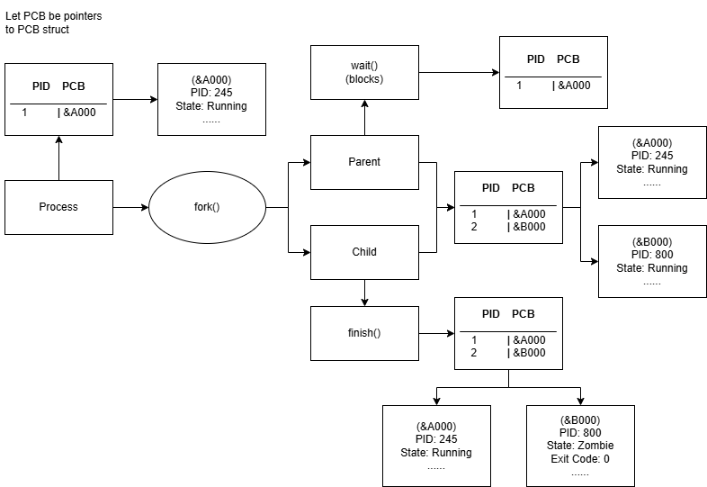

So, now the reason why the parent needs to call wait after sending the shutdown signal is because we don’t want to leave the child hanging in the OS’ process table not cleaned up. The child would be considered a dead process and not running, so killing it via kill -9 wouldn’t work since it’s already dead, but it still lingers in the OS process table. If in the illustration we didn’t wait(), then the table would still contain &A000 and &B000, &B000 would just remain in a dead state.

TLDR:
A zombie process is a process that lingers in the process table in a dead state. The parent must call wait() or waitpid() to clean up said zombie process and remove it from the process table.

Q2: In this lab, each child process monitors one network interface. Research one Linux command or file that can be used to inspect network interface statistics, such as /sys/class/net, ip -s link, or ifconfig. What information can be collected from it?

Command: ethtool -S <network_interface>

This command is a way to query or control network drivers/settings. The -S flag stands for statistics and prints out the detailed analysis of the specified network interface. Some examples of information that can be collected from it are as follows:

(rx = received, tx = sent)

Command(s) | Meaning
Rx_packets, tx_packets | Packets received and sent out respectively
Rx_bytes, tx_bytes | Received and sent out in bytes respectively
Rx_broadcast, tx_broadcast, rx_multicast, tx_multicast | How many broadcasts & multicasts the device received, sent out (messages to all devices (broadcast) and messages to specific devices (multicast))
Rx_errors, tx_errors | Number of corrupted, dropped, problematic packets
collisions, tx_single_coll_ok, tx_multi_coll_ok, tx_abort_late_coll | A counter of how many and kind of packet collisions have occurred (2+ devices transmitting data simultaneously on a shared network)

So in a general sense, it tells us about a network interfaces’ packets received and sent status, any errors or issues, flow control and checksum states.

Output:
